OPERATING SYSTEMS / SYSTEM SOFTWARE LAB
Practical 2
Name: Charishma
Roll No: 2520030140
Section: 8
Date: 22-08-2026

Aim:
To develop a C program using open(), read(), write() and close() to copy one file into another and trace system calls using strace.
Program:
#include <stdio.h>
#include <fcntl.h>
#include <unistd.h>
#include <stdlib.h>

#define BUFFER_SIZE 1024

int main(int argc, char *argv[])
{
int source, destination;
char buffer[BUFFER_SIZE];
ssize_t bytes_read, bytes_written;

if (argc != 3)
{
printf("Usage: %s <source> <destination>\n", argv[0]);
return 1;
}

/* Open source file */
source = open(argv[1], O_RDONLY);

if (source == -1)
{
perror("Error opening source file");
return 1;
}

/* Open destination file */
destination = open(argv[2], O_WRONLY | O_CREAT | O_TRUNC, 0644);

if (destination == -1)
{
perror("Error opening destination file");
close(source);
return 1;
}

/* Read from source and write to destination */
while ((bytes_read = read(source, buffer, BUFFER_SIZE)) > 0)
{
bytes_written = write(destination, buffer, bytes_read);

if (bytes_written != bytes_read)
{
perror("Error writing to destination file");
close(source);
close(destination);
return 1;
}
}

if (bytes_read == -1)
{
perror("Error reading source file");
}

/* Close files */
close(source);
close(destination);

printf("File copied successfully.\n");

return 0;
}
Execution:
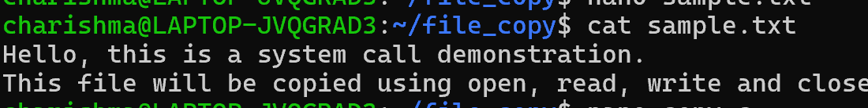
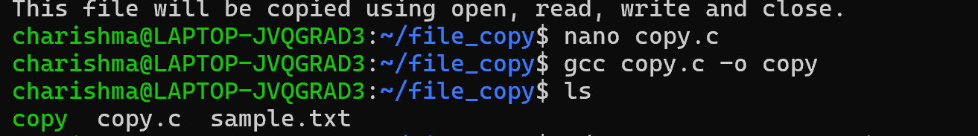
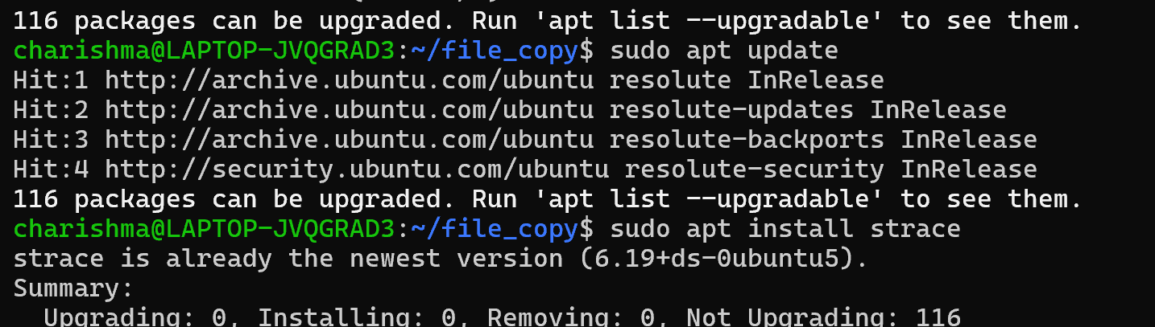
Output:
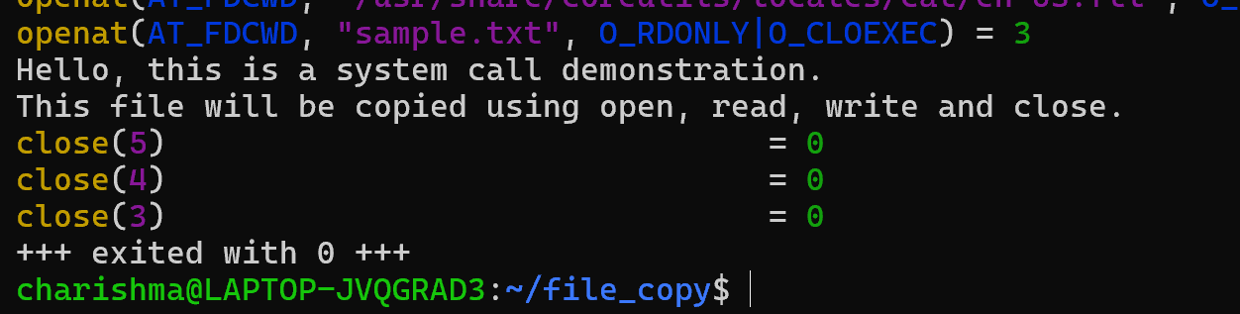
Result:
The file was successfully copied using system calls, and the system calls generated by cat were successfully traced using strace.

